Justin Carlson

2/22/23

CPE 233-07

Prof. Mealy

**Experiment 6 Submission**

**Executive Summary:**

This experiment involved implementing nearly the entire RISC-V instruction set for the MCU. Instructions were added by modifying the FSM and decoder files to include cases for values of func3, func7, and the opcodes.

**Experiment Demo**: <https://youtu.be/tljQosNzo3w>

**Questions**:

1. Briefly explain whether the use of enumerated types in SystemVerilog increases the size of the

synthesized design.

Looking through the synthesized design, there are no indicators for the enumerated types anywhere in the diagram which leads me to believe it doesn’t affect the size. My guess would be that it’s read during synthesis in order to compile the program, and when Vivado builds the design it uses the plain values of these types to create the board.

2. Briefly describe how the MCU differentiates between load/store and Input/Output instructions.

For this problem, we’re not talking about the opcodes associated with those instructions.

The address in the memory tells the MCU whether it belongs in the memory space or the IO space. Memory occupies the address range 0x0 to 0xFFFF while IO occupies the space between 0x10000 and 0xFFFFFFFF.

3. Briefly but completely describe why the load-type instructions (lb, lbu, lh, lhu, and lw) require

three cycles to execute.

The fetch cycles behaves like all other instructions as normal, but the load instructions have different timings. The execute state for the load instructions are only capable of enabling the memory read on that t-cycle. A simultaneous read + write cannot be done on the same execute cycle, so for load instructions we have a writeback state after the execute that actually writes the memory value into a register.

4. What is the maximum number of different unique bits that you could configure the RISC-V MCU

to input? Briefly but fully explain. Write an equation; don’t generate the final number.

Since the IO space of the MCU falls into the range in memory between 0x00010000 and 0xFFFFFFFF, the maximum of addressable unique bits would be (232 – 216) * 32 bits.

5. What is the maximum number of different unique bits that you could configure the RISC-V MCU

to output? Briefly but fully explain. Write an equation; don’t generate the final number.

As the MCU IO space is shared for inputs and outputs, the number of output bits will be the same as the number of input bits, or (232 – 216) * 32 bits.

6. Can you use the same I/O port address for both inputs and outputs in the same complete RISC-V

MCU implementation? Briefly explain.

No, using the same address for inputs and outputs would cause you to overwrite the data at that memory location. Different ports must be chosen for all IO in your MCU.

7. If the “memory” portion of RISC-V MCU memory changed from 2^16 x 8 to 2^10 x 8, what would

be the new maximum number of unique input and/or output addresses that the hardware could

use? Answer this problem with an equation. Read the problem very carefully.

Since the number of IO addresses is the total memory capacity minus the space dedicated for memory, the number of unique addresses is (232 – 210).

8. In assembly language-land, we refer to instructions that do nothing as “nops” (pronounced

“know ops”). In academia, we refer to “nops” as administrators. The nop instruction in RISC-V

MCU is a pseudoinstruction. Show at least four different ways you can implement a nop

instruction in RISC-V assembly language.

1. addi x0, x0, 0
2. jal x0, next

next: (next instruction)

1. beqz x0, next

next: (next instruction)

1. mv x0, x0

9. Briefly describe whether the FSM used in the RISC-V OTTER MCU is a Mealy or a Moore-type

FSM.

The FSM is a Moore type, as none of the inputs directly trigger any specific FSM outputs. This FSM is only sensitive to changes in the reset and opcode inputs, and no Mealy outputs are present in any of their respective state changes.

10. Briefly explain what attribute of the RISC-V MCU is preventing you from executing all 2-cycle

instructions in one clock cycle.

Program memory reads are synchronous, so one t-cycle is required to actually read the memory then another is needed to actually execute it.

11. Can I possibly use the RISC-V to implement a program that utilizes 40 stacks? If so, briefly but

completely explain how this can be done using the ISA and not changing hardware. Assume the

amount of memory is not an issue for this problem.

Memory segments can be allocated for each stack like in the normal MCU, where we break our data segment for example into a collection of stacks. We can use the set of registers as stack pointers, if we’re willing to fit multiple stack pointers into each register since their address will be small enough. Otherwise, we can also put the stack pointers into a known place in memory and load/store them when we need to access each stack and operate on it.

12. How much memory do the control units in this experiment contain?

The memory of the control units is determined by the size of the state registers, and since we have 4 states, our CU memory can be fit into 2 bits.

13. Which signal(s) in the control units represent the memory elements for the control unit.

The signal in charge representing the memory elements in the CU is the state that the PS variable is assigned to.

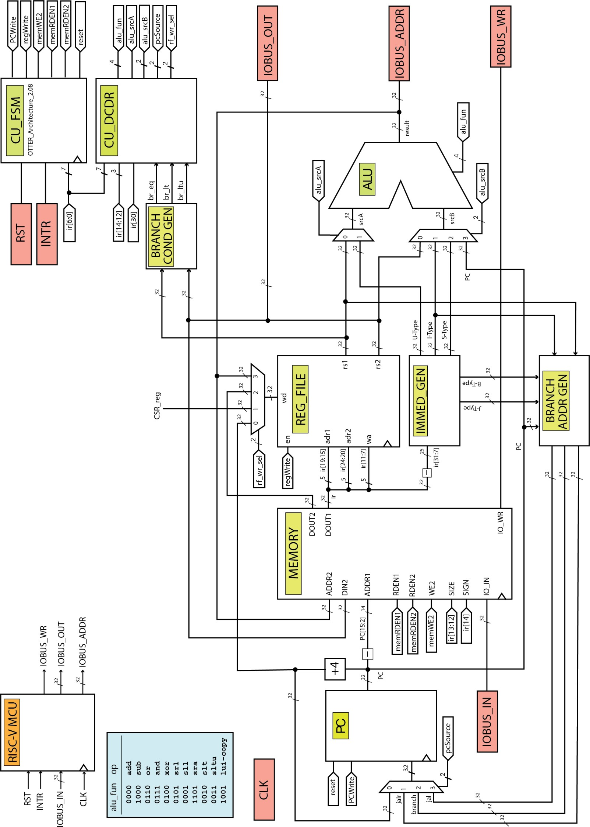

**Verilog Code**:

**Decoder:**

`timescale 1ns / 1ps

//////////////////////////////////////////////////////////////////////////////////

// Company: Ratner Surf Designs

// Engineer: James Ratner

//

// Create Date: 01/29/2019 04:56:13 PM

// Design Name:

// Module Name: CU_Decoder

// Project Name:

// Target Devices:

// Tool Versions:

// Description: Modified by Justin Carlson

//

// Dependencies:

//

// CU_DCDR my_cu_dcdr(

// .br_eq (),

// .br_lt (),

// .br_ltu (),

// .opcode (), //- ir[6:0]

// .func7 (), //- ir[30]

// .func3 (), //- ir[14:12]

// .alu_fun (),

// .pcSource (),

// .alu_srcA (),

// .alu_srcB (),

// .rf_wr_sel () );

//

//

// Revision:

// Revision 1.00 - File Created (02-01-2020) - from Paul, Joseph, & Celina

// 1.01 - (02-08-2020) - removed unneeded else's; fixed assignments

// 1.02 - (02-25-2020) - made all assignments blocking

// 1.03 - (05-12-2020) - reduced func7 to one bit

// 1.04 - (05-31-2020) - removed misleading code

// Additional Comments:

//

//////////////////////////////////////////////////////////////////////////////////

module CU_DCDR(

input br_eq,

input br_lt,

input br_ltu,

input [6:0] opcode, //- ir[6:0]

input func7, //- ir[30]

input [2:0] func3, //- ir[14:12]

output logic [3:0] alu_fun,

output logic [1:0] pcSource,

output logic alu_srcA,

output logic [1:0] alu_srcB,

output logic [1:0] rf_wr_sel );

//- datatypes for RISC-V opcode types

typedef enum logic [6:0] {

LUI = 7'b0110111,

AUIPC = 7'b0010111,

JAL = 7'b1101111,

JALR = 7'b1100111,

BRANCH = 7'b1100011,

LOAD = 7'b0000011,

STORE = 7'b0100011,

OP_IMM = 7'b0010011,

OP_RG3 = 7'b0110011

} opcode_t;

opcode_t OPCODE; //- define variable of new opcode type

assign OPCODE = opcode_t'(opcode); //- Cast input enum

//- datatype for func3Symbols tied to values

typedef enum logic [2:0] {

//BRANCH labels

BEQ = 3'b000,

BNE = 3'b001,

BLT = 3'b100,

BGE = 3'b101,

BLTU = 3'b110,

BGEU = 3'b111

} func3_t;

func3_t FUNC3; //- define variable of new opcode type

assign FUNC3 = func3_t'(func3); //- Cast input enum

always_comb

begin

//- schedule all values to avoid latch

pcSource = 2'b00; alu_srcB = 2'b00; rf_wr_sel =

2'b00;

alu_srcA = 1'b0; alu_fun = 4'b0000;

case(OPCODE)

LUI:

begin

rf_wr_sel = 2'b11;

alu_srcA = 1'b1;

alu_fun = 4'b1001;

end

AUIPC:

begin

rf_wr_sel = 2'b11;

alu_srcA = 1'b1;

alu_srcB = 2'b11;

end

JAL:

begin

pcSource = 2'b11;

end

JALR:

begin

pcSource = 2'b01;

end

LOAD:

begin

alu_srcA = 1'b0;

alu_srcB = 2'b01;

rf_wr_sel = 2'b10;

end

STORE:

begin

alu_srcA = 1'b0;

alu_srcB = 2'b10;

end

BRANCH: // Individual instructions labeled for clarity despite their glaring similarities

begin

alu_fun = 4'b0000;

alu_srcA = 1'b0;

rf_wr_sel = 2'b00;

alu_srcB = 2'b11;

case(FUNC3)

BEQ:

begin

if (br_eq) pcSource = 2'b10;

end

BNE:

begin

if (~br_eq) pcSource = 2'b10;

end

BLT:

begin

if (br_lt) pcSource = 2'b10;

end

BGE:

begin

if (br_eq || ~br_lt) pcSource = 2'b10;

end

BLTU:

begin

if (br_ltu) pcSource = 2'b10;

end

BGEU:

begin

if (br_eq || ~br_ltu) pcSource = 2'b10;

end

endcase

end

OP_IMM:

begin

rf_wr_sel = 2'b11;

alu_srcA = 1'b0;

alu_srcB = 2'b01;

case(FUNC3)

3'b000: // ADDI

begin

alu_fun = 4'b0000;

end

3'b010: // SLTI

begin

alu_fun = 4'b0010;

end

3'b011: // SLTIU

begin

alu_fun = 4'b0011;

end

3'b110: // ORI

begin

alu_fun = 4'b0110;

end

3'b100: // XORI

begin

alu_fun = 4'b0100;

end

3'b111: // ANDI

begin

alu_fun = 4'b0111;

end

3'b001: // SLLI

begin

alu_fun = 4'b0001;

end

3'b101: // SRLI & SRAI

begin

case(func7)

1'b0: // SRLI

begin

alu_fun = 4'b0101;

end

1'b1: // SRAI

begin

alu_fun = 4'b1101;

end

endcase

end

default:

begin

pcSource = 2'b00;

alu_fun = 4'b0000;

alu_srcA = 1'b0;

alu_srcB = 2'b01;

rf_wr_sel = 2'b11;

end

endcase

end

OP_RG3:

begin

alu_srcA = 1'b0;

alu_srcB = 2'b00;

rf_wr_sel = 2'b11;

case(FUNC3)

3'b000: // ADD & SUB

begin

case(func7)

1'b0: // ADD

begin

alu_fun = 4'b0000;

end

1'b1: // SUB

begin

alu_fun = 4'b1000;

end

endcase

end

3'b001: // SLL

begin

alu_fun = 4'b0001;

end

3'b010: // SLT

begin

alu_fun = 4'b0010;

end

3'b011: // SLTU

begin

alu_fun = 4'b0011;

end

3'b100: // XOR

begin

alu_fun = 4'b0100;

end

3'b101: // SRL & SRA

begin

case(func7)

1'b0: // SRL

begin

alu_fun = 4'b0101;

end

1'b1: // SRA

begin

alu_fun = 4'b1101;

end

endcase

end

3'b110: // OR

begin

alu_fun = 4'b0110;

end

3'b111: // AND

begin

alu_fun = 4'b0111;

end

default:

begin

alu_srcA = 1'b0;

alu_srcB = 2'b00;

rf_wr_sel = 2'b11;

end

endcase

end

default:

begin

pcSource = 2'b00;

alu_srcB = 2'b00;

rf_wr_sel = 2'b00;

alu_srcA = 1'b0;

alu_fun = 4'b0000;

end

endcase

end

endmodule

**FSM:**

`timescale 1ns / 1ps

//////////////////////////////////////////////////////////////////////////////////

// Company: Ratner Surf Designs

// Engineer: James Ratner

//

// Create Date: 01/07/2020 09:12:54 PM

// Design Name:

// Module Name: top_level

// Project Name:

// Target Devices:

// Tool Versions:

// Description: Control Unit Template/Starter File for RISC-V OTTER

//

// //- instantiation template

// CU_FSM my_fsm(

// .intr (xxxx),

// .clk (xxxx),

// .RST (xxxx),

// .opcode (xxxx), // ir[6:0]

// .pcWrite (xxxx),

// .regWrite (xxxx),

// .memWE2 (xxxx),

// .memRDEN1 (xxxx),

// .memRDEN2 (xxxx),

// .reset (xxxx) );

//

// Dependencies:

//

// Revision:

// Revision 1.00 - File Created - 02-01-2020 (from other people's files)

// 1.01 - (02-08-2020) switched states to enum type

// 1.02 - (02-25-2020) made PS assignment blocking

// made rst output asynchronous

// 1.03 - (04-24-2020) added "init" state to FSM

// changed rst to reset

// 1.04 - (04-29-2020) removed typos to allow synthesis

// 1.05 - (10-14-2020) fixed instantiation comment (thanks AF)

// 1.06 - (12-10-2020) cleared most outputs, added commentes

//

//////////////////////////////////////////////////////////////////////////////////

module CU_FSM(

input intr,

input clk,

input RST,

input [6:0] opcode, // ir[6:0]

output logic pcWrite,

output logic regWrite,

output logic memWE2,

output logic memRDEN1,

output logic memRDEN2,

output logic reset

);

typedef enum logic [1:0] {

st_INIT,

st_FET,

st_EX,

st_WB

} state_type;

state_type NS,PS;

//- datatypes for RISC-V opcode types

typedef enum logic [6:0] {

LUI = 7'b0110111,

AUIPC = 7'b0010111,

JAL = 7'b1101111,

JALR = 7'b1100111,

BRANCH = 7'b1100011,

LOAD = 7'b0000011,

STORE = 7'b0100011,

OP_IMM = 7'b0010011,

OP_RG3 = 7'b0110011

} opcode_t;

opcode_t OPCODE; //- symbolic names for instruction opcodes

assign OPCODE = opcode_t'(opcode); //- Cast input as enum

//- state registers (PS)

always @ (posedge clk)

if (RST == 1)

PS <= st_INIT;

else

PS <= NS;

always_comb

begin

//- schedule all outputs to avoid latch

pcWrite = 1'b0; regWrite = 1'b0; reset = 1'b0;

memWE2 = 1'b0; memRDEN1 = 1'b0; memRDEN2 = 1'b0;

case (PS)

st_INIT: //waiting state

begin

reset = 1'b1;

NS = st_FET;

end

st_FET: //fetch state

begin

memRDEN1 = 1'b1;

memRDEN2 = 1'b0;

NS = st_EX;

end

st_EX: //decode + execute

begin

pcWrite = 1'b1;

case (OPCODE)

LOAD:

begin

regWrite = 1'b0;

pcWrite = 1'b0;

memRDEN2 = 1'b1;

NS = st_WB;

end

STORE:

begin

regWrite = 1'b0;

memWE2 = 1'b1;

NS = st_FET;

end

BRANCH:

begin

NS = st_FET;

end

LUI: // U-type

begin

regWrite = 1'b1;

NS = st_FET;

end

AUIPC: // U-type

begin

regWrite = 1'b1;

NS = st_FET;

end

OP_IMM: // I-type arithmetic

begin

regWrite = 1'b1;

NS = st_FET;

end

OP_RG3: // R-type instructions

begin

regWrite = 1'b1;

NS = st_FET;

end

JAL:

begin

regWrite = 1'b1;

NS = st_FET;

end

JALR:

begin

regWrite = 1'b1;

NS = st_FET;

end

default:

begin

NS = st_FET;

end

endcase

end

st_WB:

begin

regWrite = 1'b1;

pcWrite = 1'b1;

NS = st_FET;

end

default: NS = st_FET;

endcase //- case statement for FSM states

end

endmodule

Programming Assignment:

Write a RISC-V program that implements a unique display on the development board. Upon   
programming the FPGA, the right-most LED on the development board will blink at about a 2Hz rate.   
When the user presses the left-most button on the dev board, a single LED lights as it moves from the   
right-most LED to the left-most LED; the left-most LED then blinks at the 2Hz rate waiting for a button   
release and then a button press. When the user releases the button and presses it again, the “lit” LED   
moves one lit LED at a time until it reaches the right-most LED. This functionality happens continuously.

init: li x20,0x11008004 # button input port addr

li x21,0x1100C000 # LED output port addr

li x9, 0x8000 # constant upper value

li x10, 1 # value of the led

li x11, 1 # constant lower value

loop: sw x10, 0(x21) # activates light

lw x25, 0(x20) # loads button IO

sw x0, 0(x21) # deactivates light

bnez x25, pick # checks if button pressed

j loop

unpress: sw x10, 0(x21) # activates light

lw x25, 0(x20) # loads button IO

sw x0, 0(x21) # deactivates light

beqz x25, loop # checks if button unpressed

j unpress

pick: beq x10, x11, LtoH # decides whether to change leds from low to high or high to low

j HtoL

HtoL: beq x10, x11, unpress # checks if done

srli x10, x10, 1 # shifts value to right

sw x10, 0(x21) # reassigns led

j HtoL

LtoH: beq x10, x9, unpress # checks if done

slli x10, x10, 1 # shifts value to left

sw x10, 0(x21) # reassigns led

j LtoH

This program works by first initializing all the values and putting the program into a loop. This loop waits for a button press to be made, and the light flickers on and off until it waits. When it senses a button change, based on its current LED value, the program determines whether to shift it left or right. It then shifts it until its on the far side either to the left or right and then waits for the button to be released while flickering the LED before entering into the original loop again when the buttons are unpressed.

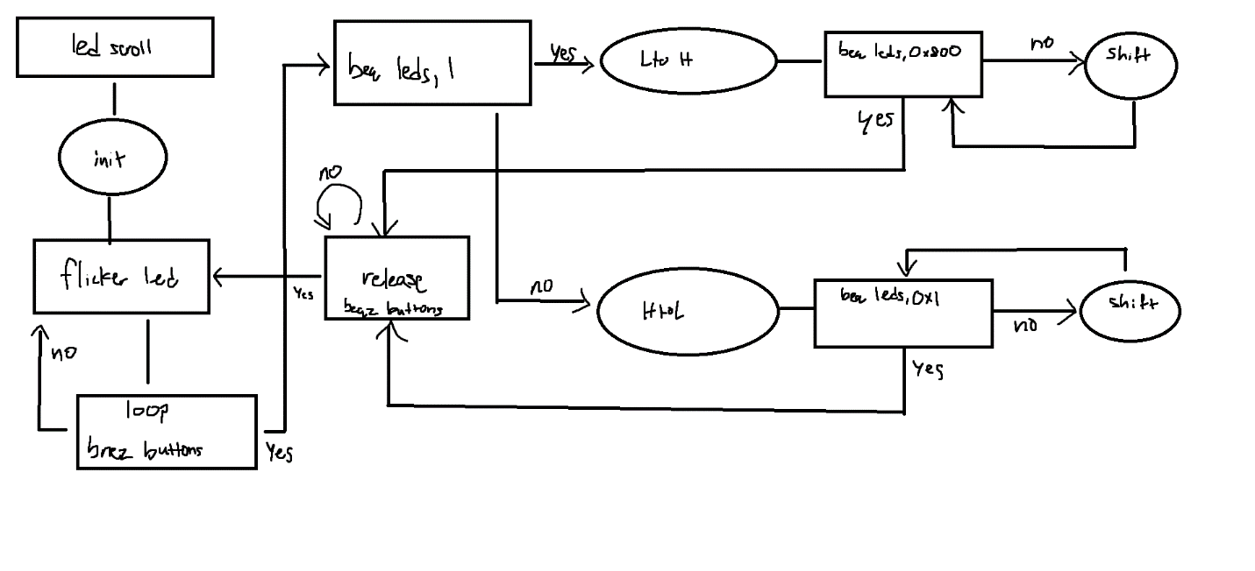

Demo: <https://youtu.be/0FM4n2m2xKI>

**Hardware Assignment**:

You need to the RISC-V MCU of clear alternating output values, meaning that output operations output

a value, then output zero, then outputs a value, etc. on successive output operations. For this problem,

describe a modification to the RISC-V schematic to implement this change and show a schematic for

your added hardware. All modifications for this problem should be on the top schematic level; don’t

change any of the current modules in the RISC-V Otter schematic.

In order to only display a value every other time the MCU writes out, we can use a D-type flip flop with it’s not output assigned to its input, D, to toggle our output. Now, IOBUS_WR acts as a clock for the flip flop, and on the rising edge it will toggle the current value in the flip flop. If we pass this output to the selector for a 2:1 mux, and have inputs of our IOBUS_OUT and ground, then our data will only display on the board for every other time the IOBUS_WR signal is set to high.

